Installing PostgreSQL and PGAdmin

1. Go to <https://www.postgresql.org/download/> and select your OS

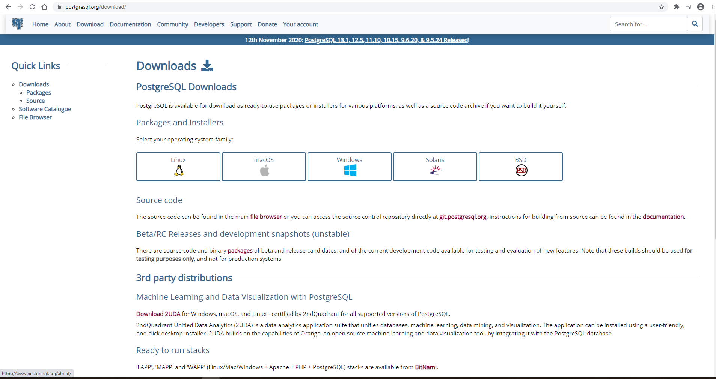

1. Click on “Download the Installer” and then download the most recent version available (V 13 as of this documentation)

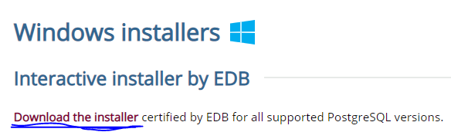

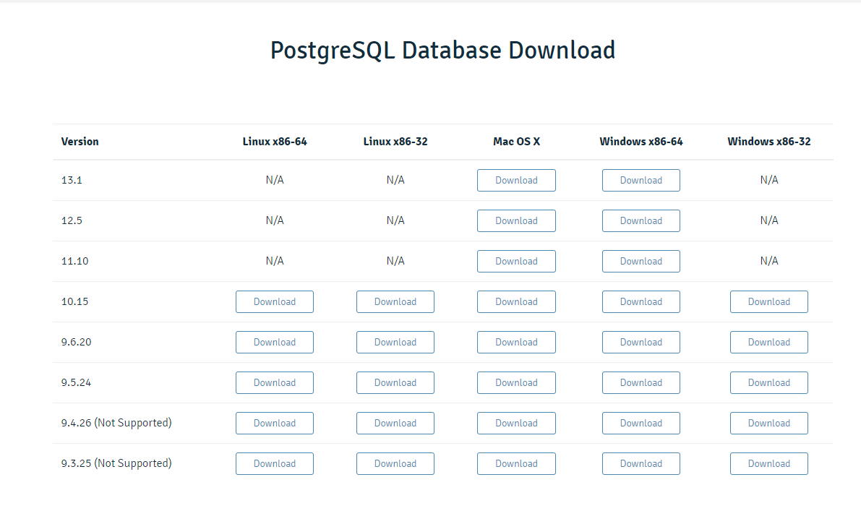

1. Run the installer from the download in browser or your Downloads folder

 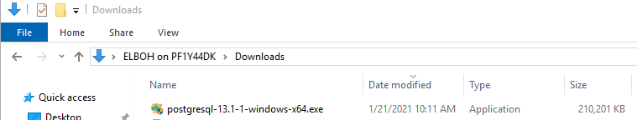

1. Follow the setup prompt with defaults until it asks for a superuser password

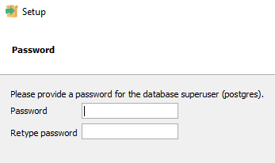

1. Enter a password you’ll be sure to remember (this will be used later to access the DB)
2. Continue the setup with defaults until installation begins
3. Click finish (This will launch Stack Builder)
4. In Stack builder, select the “PostgreSQL 13 (x64) on port 5432” option and click Next

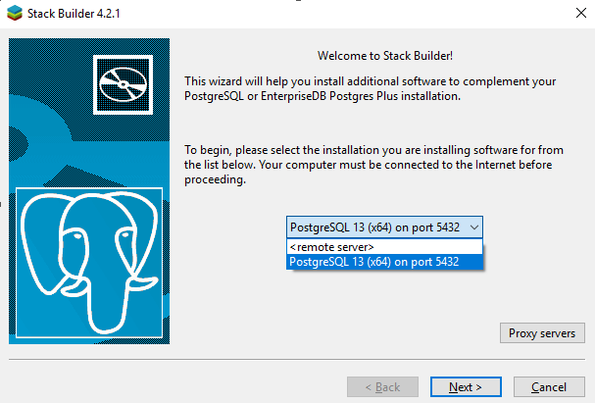

1. From the next screen, we can install additional add ons or drivers as wanted, but we don’t need any right now so hit Cancel  
   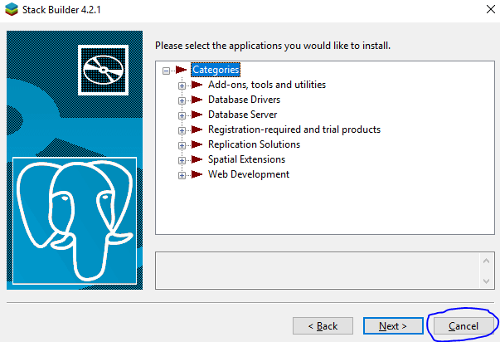
2. Open the start menu and locate the PostgreSQL 13 folder, expand it and click on pgAdmin 4

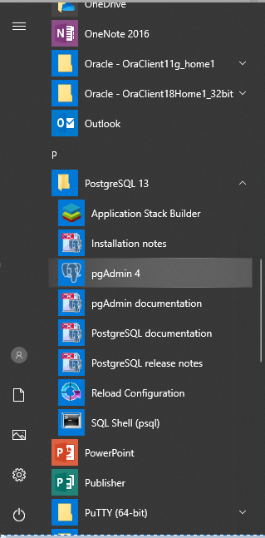

1. You will be prompted for a master password. Make this one easy to remember as well as you will need it to access pg Admin

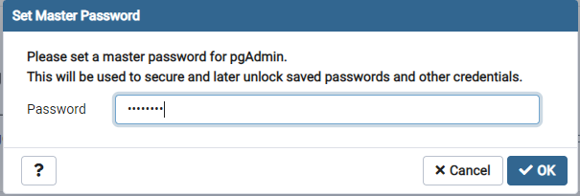

1. Click the Servers dropdown on the left to see your PostgreSQL 13 server and double click on it



1. Enter your password from Step 5 to connect

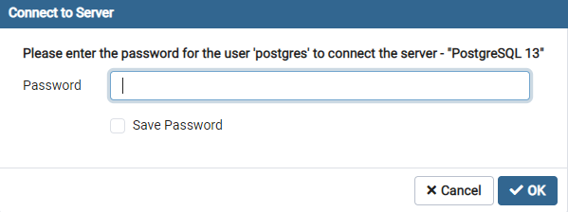

1. That’s it! You can now begin creating your own database

Video version of these instructions here: <https://www.youtube.com/watch?v=e1MwsT5FJRQ>